**Task 1 - Getting started with moqups.com account setup and tools overview**

1. Create a free account in moqups.com. Follow with the click on the a Create a Free Account. You can get this screen. Let’s go with Sign up with Google.

1. You will see this screen. Select Blank Project & Rename as “Wireframe & Mockup”

1. Drag and drop some of the objects in Stencils that you can use to create wireframe. Do not limit with what is just mentioned below.
   1. Rectangle
   2. Link
   3. Heading
   4. Paragraph
   5. Image Placeholder
   6. Banner
   7. Search

Menus & Navigation

* 1. Form Controls
  2. Table
  3. Calendar
  4. Map and
  5. Others you can use

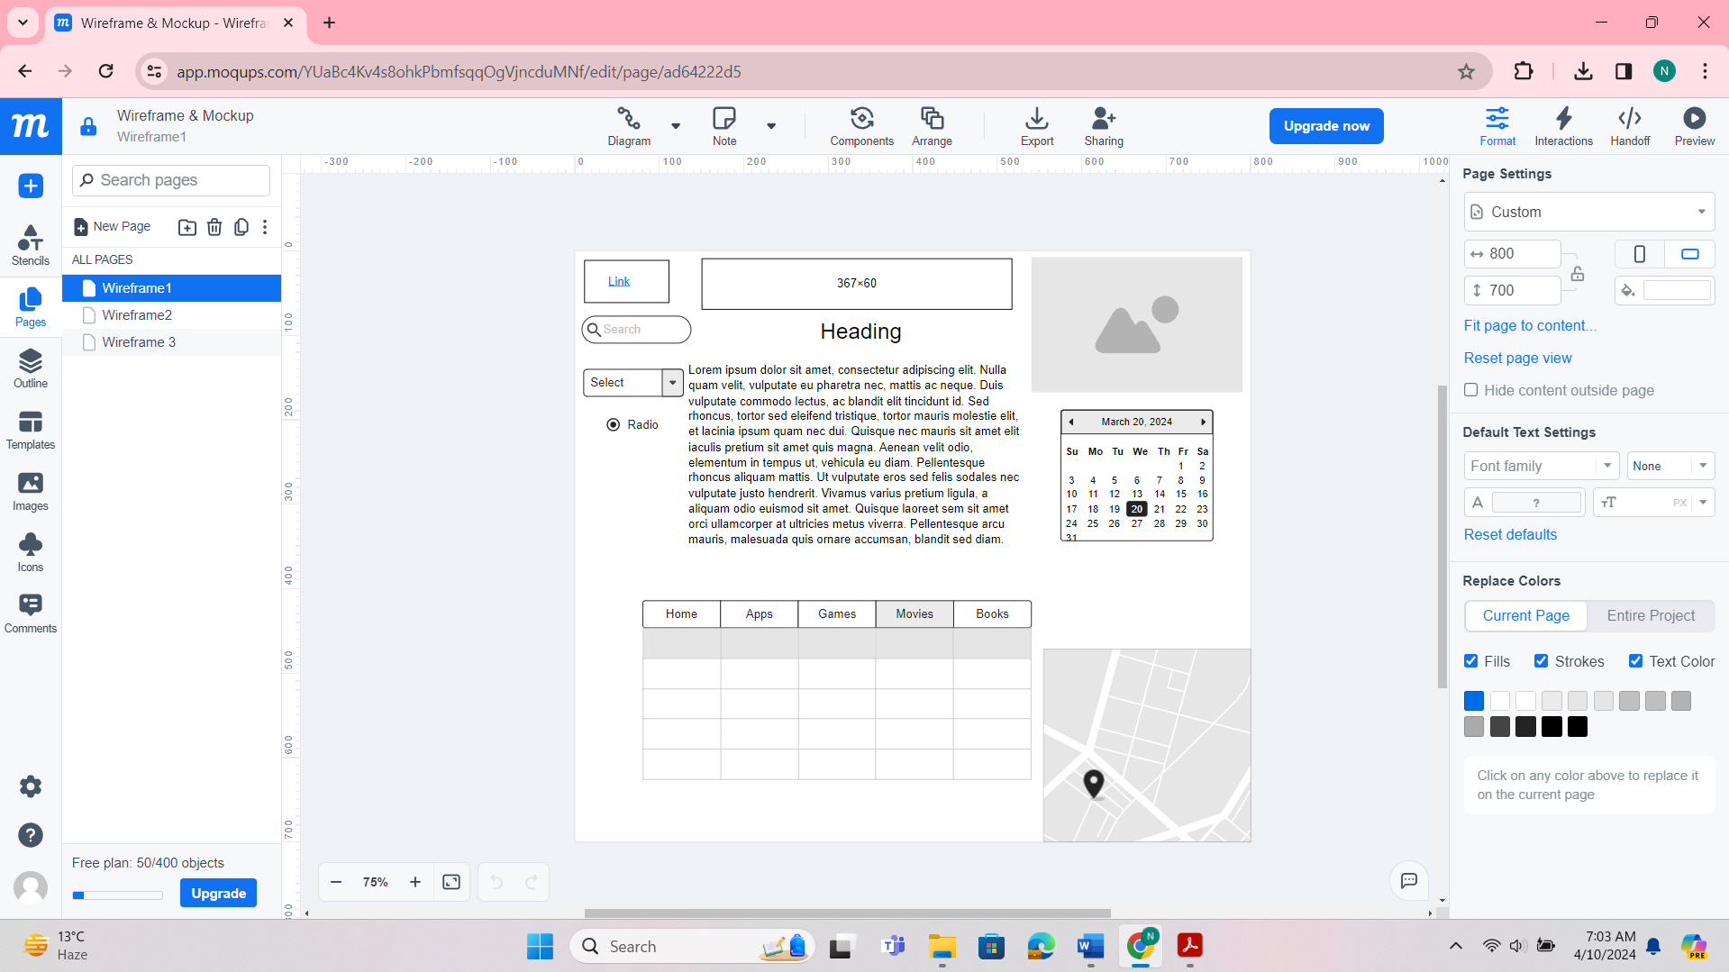

**Task 2 – Design the below like wireframe structure. Use your own creativity.**

**Task 3 – Create a mockup design like your college website’s contact us page. Use your own creativity for this design.**

